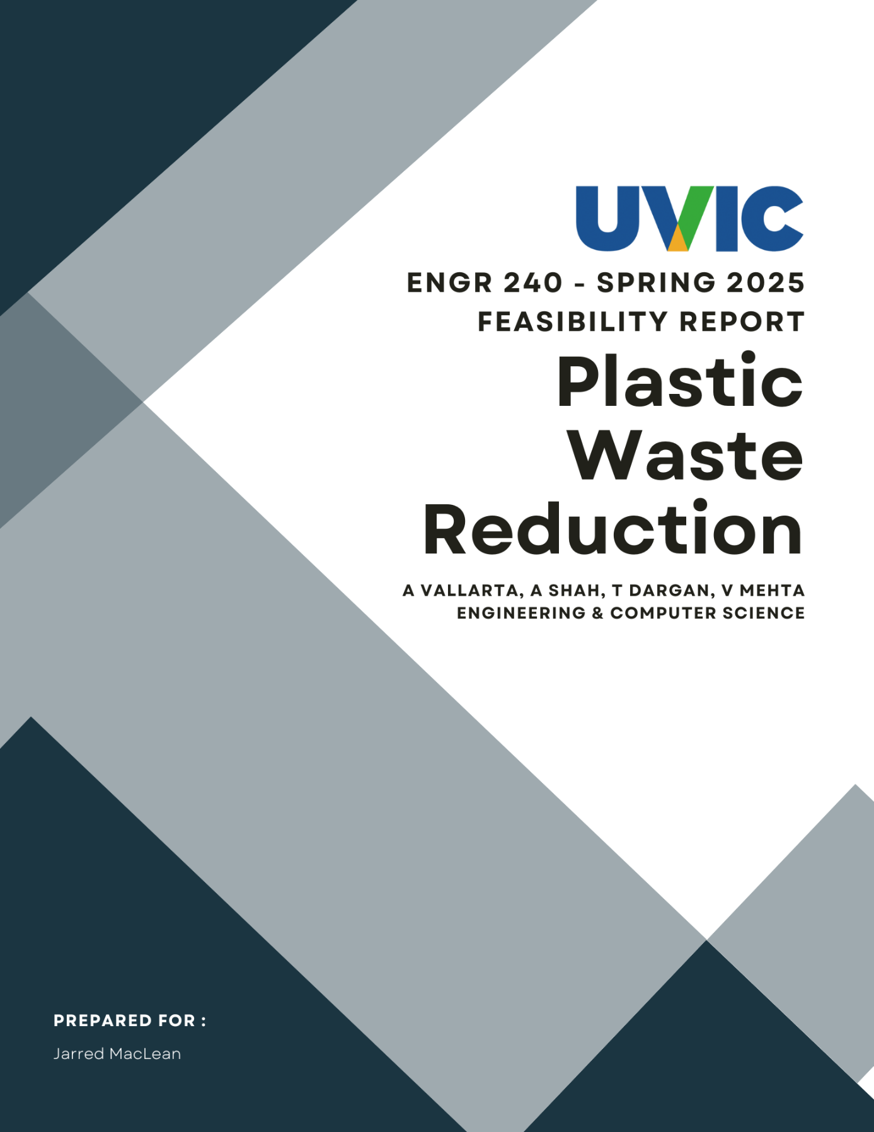

**Table of Contents**

1. Client Background 2

2. Executive Summary 3

3. Problem Definition 3

3.1 Need Statement 3

3.2 Goal Statement 3

3.3 Objectives 3

3.4 Constraints 3

3.5 Benefits 4

4. Plan of Action 4

4.1 Technical Plan 4

4.2 Management Plan 4

5. Budget 4

6. Qualification 4

7. Campus Waste & Identify Benefits 5

8. RVM Model Evaluation & Site Survey 5

9. Results 5

10. Feedback and Stakeholder Engagement 5

11. Discussion 5

12. Recommendations 5

13. Conclusion 5

References 5

Appendices 6

Table of Figures ……………………………………………………………………………………….

**Table of Figures**

This proposal examines the feasibility of using camera-assisted object identification to automate waste sorting on campus. By integrating a Raspberry Pi camera system with existing waste bins, the technology will direct trash into the appropriate compartments, thereby reducing the manual sorting workload for waste management staff.

## Client Background

The University of Victoria (UVic) is globally recognized as a leader in sustainability, ranking second in Canada and fourth worldwide for promoting sustainable cities and communities. Between 2009 and 2018, UVic increased its landfill diversion rate from 58% to 74% through effective recycling and composting initiatives. However, to achieve its ambitious goal of an 81% diversion rate as outlined in the university’s latest Strategic Plan, additional innovative methods are needed to address the challenge of plastic and improperly sorted waste, which currently account for 18% of landfill trash. With the impending closure of Hartland Landfill in 2040, UVic faces mounting pressure to enhance its waste management systems to reduce environmental and financial impacts. Working together with neighborhood associations and government may also yield insightful information and useful resources to support the institution in achieving in its sustainability objectives. More incentives for staff and students to use reusable items, including school dining discounts for bringing their own containers, could help lessen the usage of single-use plastics.

## Executive Summary

## Problem Definition

We will explore the problem definition through five key sections, the Needs and Goals Statement, Objectives, Constraints, and Benefits.

### 3.1 Need Statement

Waste management workers at the University of Victoria currently have insufficient sorting aid when collecting waste bins around campus, causing different waste to end up in the wrong bin. This process is time-consuming for the worker, costly for the University, and inefficient in general.

### 3.2 Goal Statement

The goal would be to create a more streamlined bin to landfill? Procedure, reducing manual waste sorting requirements, and enhancing UVic’s waste diversion rate to meet its 81% target.

### 3.3 Objectives

An effective solution should ideally be able to achieve the following outcomes:

* Simplify and improve the efficiency of waste segregation at the source.
* Reduce manual sorting labor for campus waste management staff.
* Increase the recycling rate of plastics, metals, and other recyclable materials.
* Contribute to UVic’s 81% landfill diversion rate target.
* Provide a scalable model for future waste management technologies.

### 3.4 Constraints

The proposed project must adhere to the following constraints:

* A maximum budget of $100,000.
* A two-year timeline for implementation.
* Compliance with UVic’s safety and environmental regulations.
* Seamless integration with existing bins and campus infrastructure.

### 3.5 Benefits

The investigation of an effective solution offers several benefits:

**3.5.1** Reduced Worker Labor: reduces the need for manual sorting, freeing up staff for

other tasks.

**3.5.2** Improved Recycling Rates: Accurate sorting at the source ensures more recyclable

materials are diverted from landfills.

**3.5.3** Cost Savings: Reduced labor hours and improved sorting efficiency and lower waste

management expenses.

**3.5.4** Sustainability Leadership: Demonstrates UVic’s commitment to environmental

innovation, reinforcing its reputation as a global sustainability leader.

## Plan of Action

Describe solution here then dive in to how we’d investigate it. Surveys? Prob online research something like:

Our plan of action is to implement an automated sorting system placed on top of existing infrastructure that auto sorts waste received through a singular universal funnel into their proper bins. We break this implementation into a technical plan, and a management plan:

### 4.1 Technical Plan

afawd

### 4.2 Management Plan

awdas

## Budget

Budgy mm money (take from pair proposal i think or is this budget for the research plan?)

## Qualification

We are four technical csc students are something good at coding and real world applications of technology (take from pair proposal)

## Campus Waste & Identify Benefits

## RVM Model Evaluation & Site Survey

## Results

## Feedback and Stakeholder Engagement

## Discussion

I can only do this after the survey comes back 🙁

Survey of the students of Engr 240

Something something the survey came back with this data broken up to a bunch of pie charts, showing that there is/is not a need for this as the sample size have shown a clear need for a 1 bin sorting system. We also see that in this pie chart showing average waste thrown out, cross referencing for the high waste producers some% live on campus, in which a sorting thingy would free up manpower for other tasks. Even for off campus student they still on average produce 1234kg in waste per day. In the case of lets say a 5% waste wrong bin percent then this much kg of waste must be manually sorted out, digging through however many rightly place waste. Due to small sample size something something

## Recommendations

## Conclusion

## References

[1] “UVic a national leader in climate and sustainability,” *UVic News*, Jun. 12, 2024. [Online]. Available: <https://www.uvic.ca/news/topics/2024+the-global-impact-rankings+mediarelease#:~:text=UVic%20is%20ranked%20second%20in,and%20communities%20(SDG%2011)>. Accessed: Mar. 11, 2025.

[2] University of Victoria, *Waste to Resource Assessment™ Report*. [Online]. Available: <https://www.uvic.ca/facilities/assets/docs/UVic-waste-assessment-report.pdf>. Accessed: Mar. 11, 2025.

[3] University of Victoria, *Distinctly UVic: A strategy for the University of Victoria*. [Online]. Available: <https://www.uvic.ca/strategic-plan/_assets/docs/uvic-strategic-plan-2023.pdf>. Accessed: Mar. 11, 2025.

[4] J. MacLean, “Request for Proposals FM/WR 0520,” University of Victoria, Victoria, BC, Canada, 2024. Accessed: Mar. 11, 2025.

[5] University of Victoria, *Climate and Sustainability Action Plan 2030*. [Online]. Available: <https://www.uvic.ca/_assets/docs/csap2030-actions.pdf>. Accessed: Mar. 11, 2025.

[6] we gotta cite our own pair report here so it’s not self plagarization

## Appendices

Table 1.

Piechart 4.

Etc. Fill as we add visuals and other thingies